Now let us see the results of the survey:   
Let's start with the first question: How often do you use mobile apps on your smartphone? The options provided were: Rarely, Occasionally, Frequently, and Very frequently. The results are as follows:

Rarely: 0%

Occasionally: 4.3%

Frequently: 34.8%

Very frequently: 60.9%

These results highlight that a majority of smartphone users (60.9%) use mobile apps very frequently, indicating that mobile apps play a significant role in their daily lives.

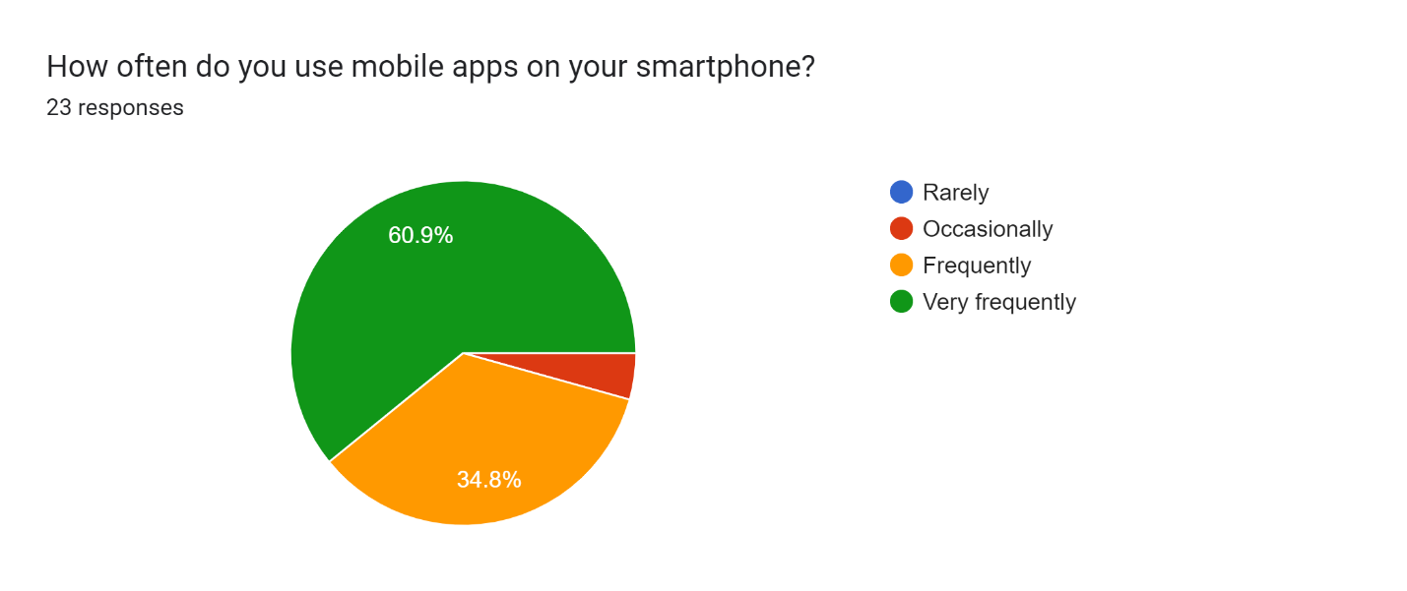

Next, we asked the participants about the number of mobile apps installed on their smartphones. The options provided were: Less than 10, 10-20, 21-30, and More than 30. The results are as follows:

Less than 10: 13%

10-20: 39.1%

21-30: 21.7%

More than 30: 21.6%

These results reveal that a significant proportion of smartphone users (39.1%) have 10-20 mobile apps installed on their smartphones, while a considerable percentage (21.6%) have more than 30 apps installed, indicating a high level of app adoption among smartphone users.

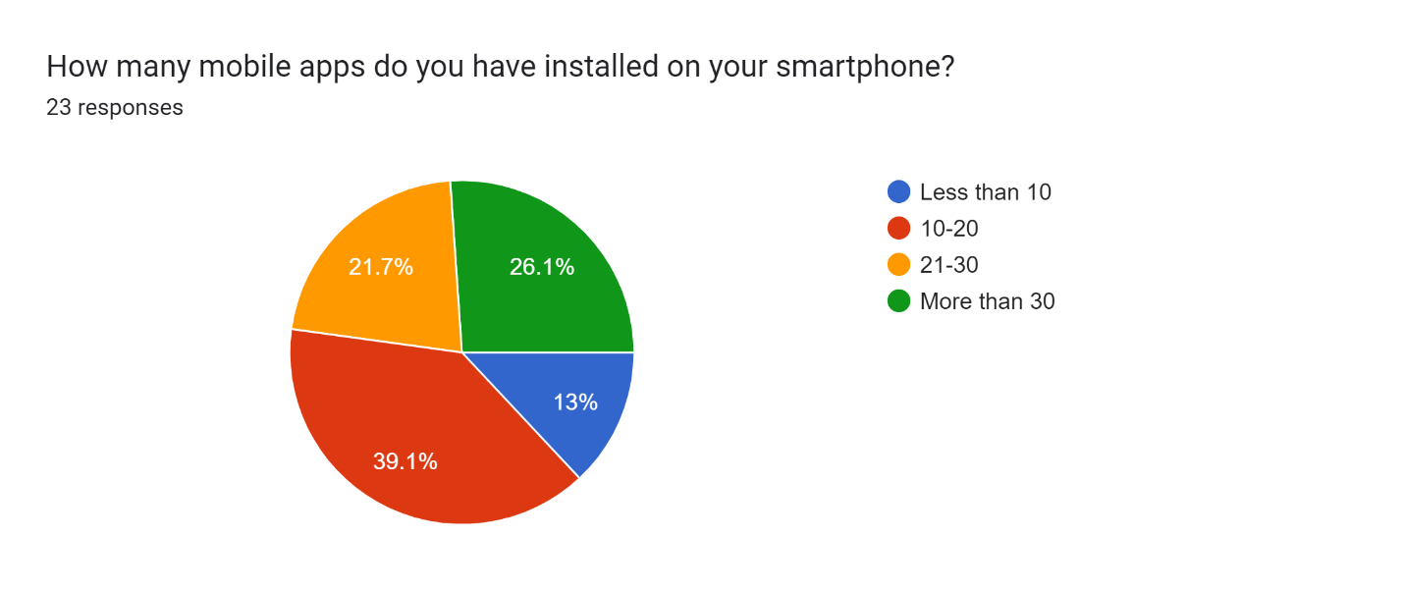

Moving on to the next question, we asked the participants about the categories of mobile apps they use the most, allowing them to select multiple options. The categories provided were: Social media, Messaging/communication, Entertainment (e.g. streaming services, gaming), Productivity (e.g. email, note-taking, calendar), Education (e.g. learning tools, study aids), Health and fitness, News and information, and Shopping. The results are as follows:

Social media: 91.3%

Messaging/communication: 82.6%

Entertainment (e.g. streaming services, gaming): 65.2%

Productivity (e.g. email, note-taking, calendar): 30.4%

Education (e.g. learning tools, study aids): 39.1%

Health and fitness: 8.7%

News and information: 4.3%

Shopping: 17.4%

These results highlight that social media (91.3%) and messaging/communication apps (82.6%) are the most commonly used categories of mobile apps among the participants, followed by entertainment apps (65.2%) and productivity apps (30.4%).

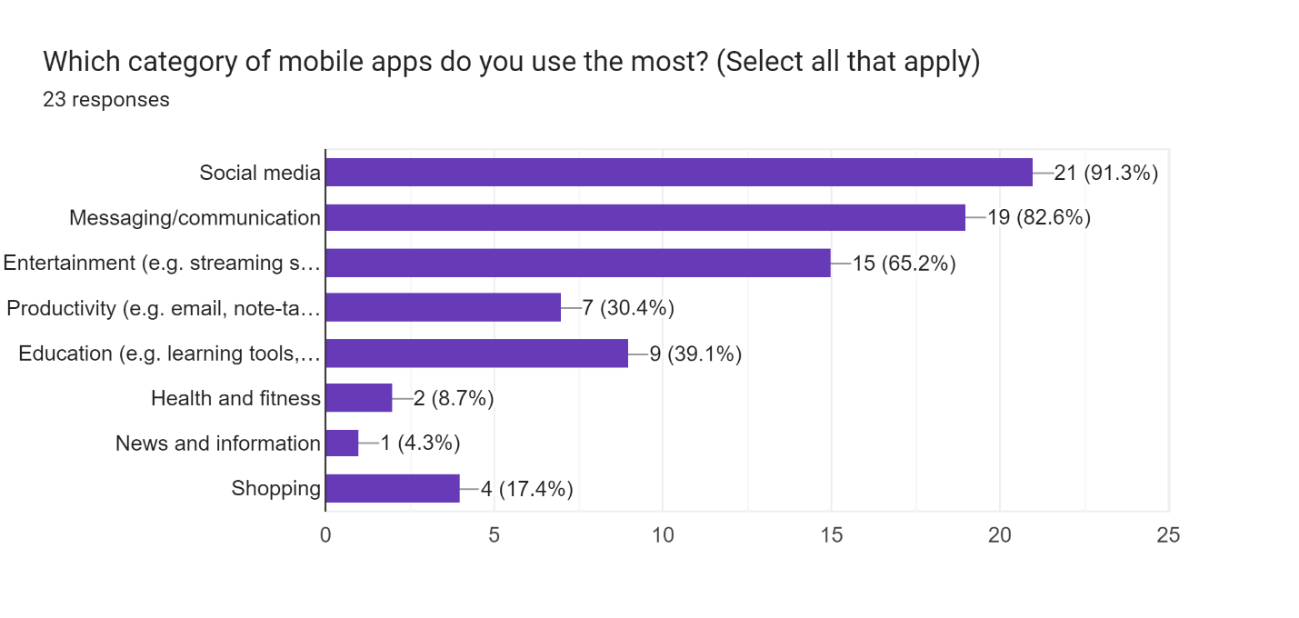

Then we asked the participants to specify which mobile apps they use the most. The results are as follows:

WhatsApp: 31.1%

Instagram: 28.9%

Facebook: 13.3%

Snapchat: 8.9%

Youtube: 6.7%

Google Classroom: 2.2%

Spotify: 4.4%

Twitter: 4.4%

These results reveal that WhatsApp (31.1%) and Instagram (28.9%) are the most commonly used mobile apps among the participants, followed by Facebook (13.3%) and Snapchat (8.9%).